Project – 2

**Deploy a Static Website on AWS**

Deploying a static website on AWS involves several steps, including setting up an S3 bucket, configuring it to host the static website, and optionally using CloudFront for content delivery.

## Table Of Contents-

* 1. Introduction
* 2. Prerequisites
* 3. Step-by-Step guide
* 4. Create an S3 Bucket
* 5. Conclusion

Created by-Teena Dixit

* 6. Dataflow Diagram



1) Introduction

This project demonstrates how to create and deploy a static website using AWS services. A static website consists of HTML, CSS, and JavaScript files that don't require server-side processing or a database. AWS S3 is used to host the website, and optionally, AWS CloudFront can be used to enhance the performance and distribution of the website content.

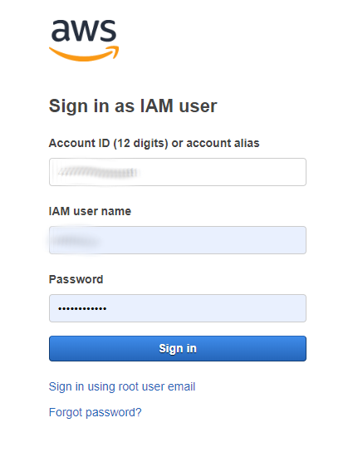2) Prerequisites

**. AWS Account**:

You need an AWS account to access AWS services.

**.Website Files** :

-HTML, CSS, and JavaScript files for your static website.

3)Step-by-Step Guide

4) Create an S3 Bucket

1.**Navigate to S3 Service**:

- In the AWS Management Console, search for S3 and open the S3 service.

2. **Create a New Bucket**:

- Click on the "Create bucket" button.

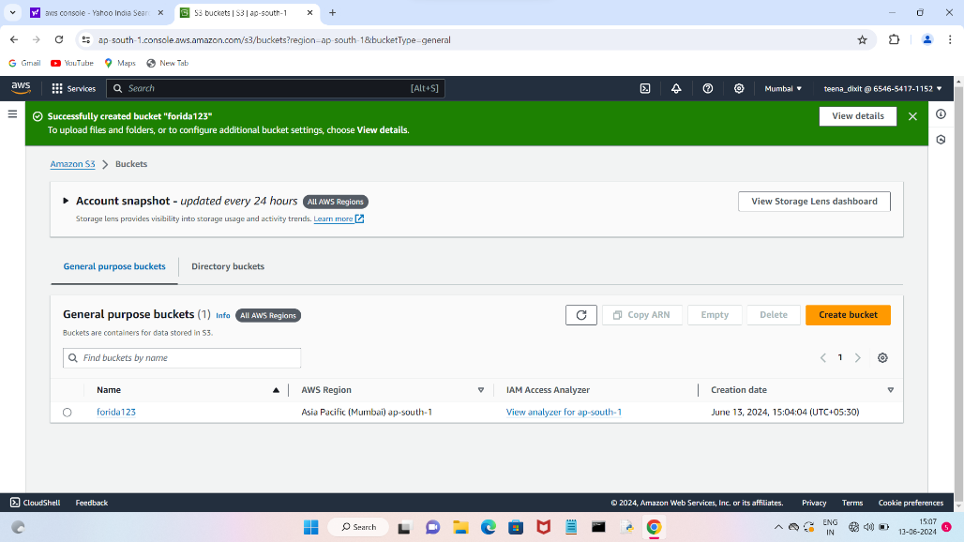

### Configure the S3 Bucket for Static Website Hosting

1. **Open Your Bucket**:

- Click on the bucket name you just created.

2. **Upload Website Files:**

- Go to the "Objects" tab. - Click on "Upload" and upload all your HTML, CSS, and JavaScript files.

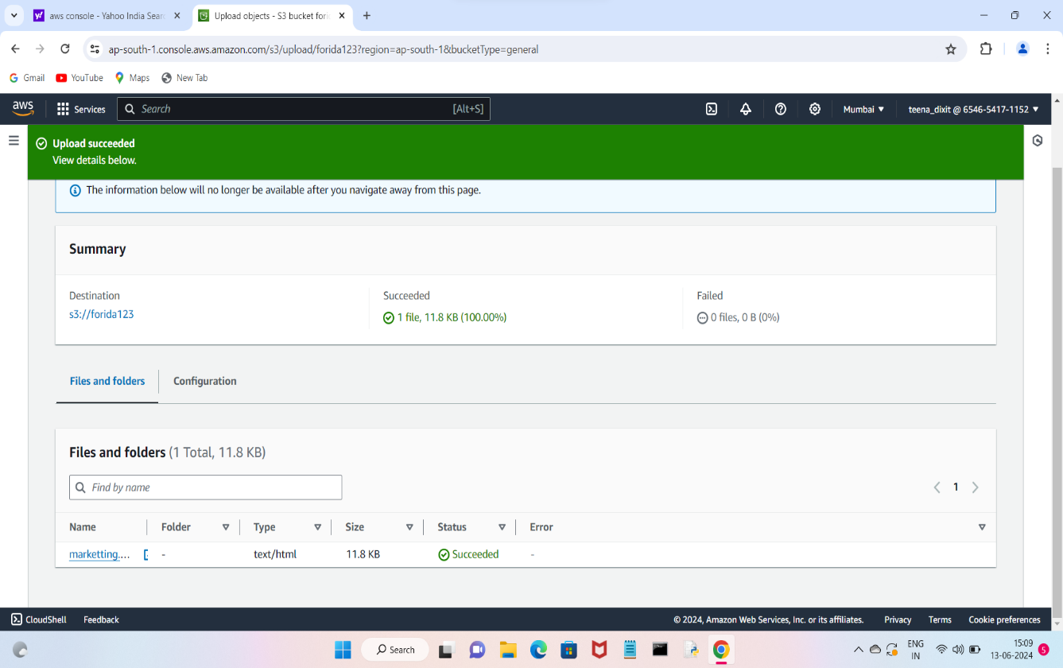

**3.Enable Static Website Hosting:-**

- Go to the "Properties" tab.

- Scroll down to the "Static website hosting" section.

- Click on "Edit".-

-Select "Enable" and choose "Host a static website"

- Save changes.

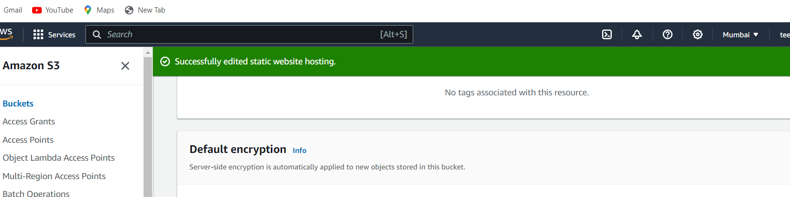

### Set Bucket Permissions

1) **Make the Bucket Public:-**

- Go to the "Permissions" tab.

-There you have to edit block public acess .

-Then save the changes and confirm it.

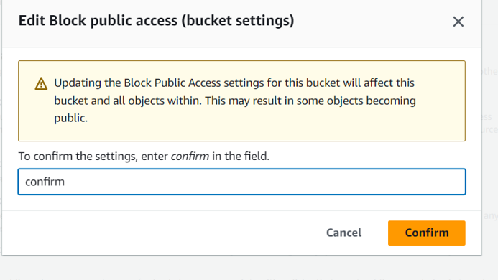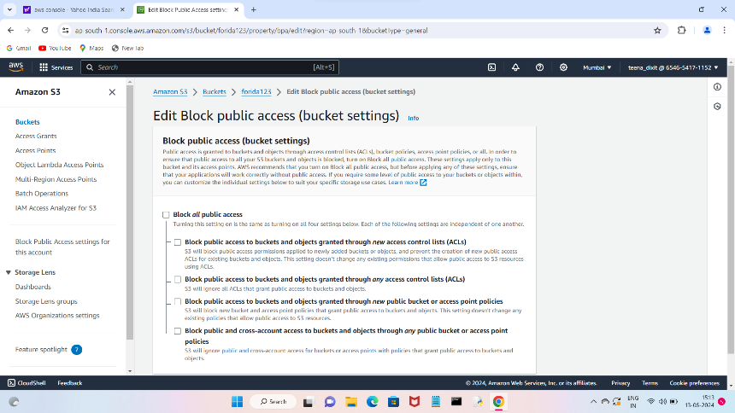

2) **Object Ownership:-**

**-**There you have to edit this setting and enable the ACL

**-**Save changes

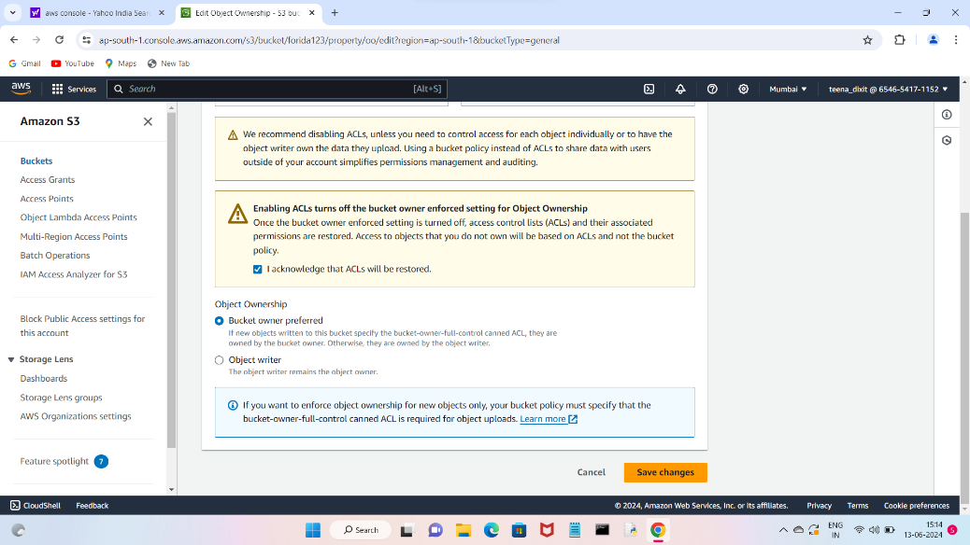

### Acess Your Website

After eveything is setup,you can acess your static website via the S3 bucket URL.



5) Conclusion

By following these steps, you can successfully deploy a static website using AWS S3 and optionally enhance it with CloudFront for better performance and reliability.

6) Dataflow Diagram

